National Park Service  U.S. Department of the Interior | Upper Delaware Scenic  and Recreational River |  | 274 River Road  Beach Lake, PA 18405-4046  570-729-8251 phone  570-729-8565 fax  www.nps.gov/upde
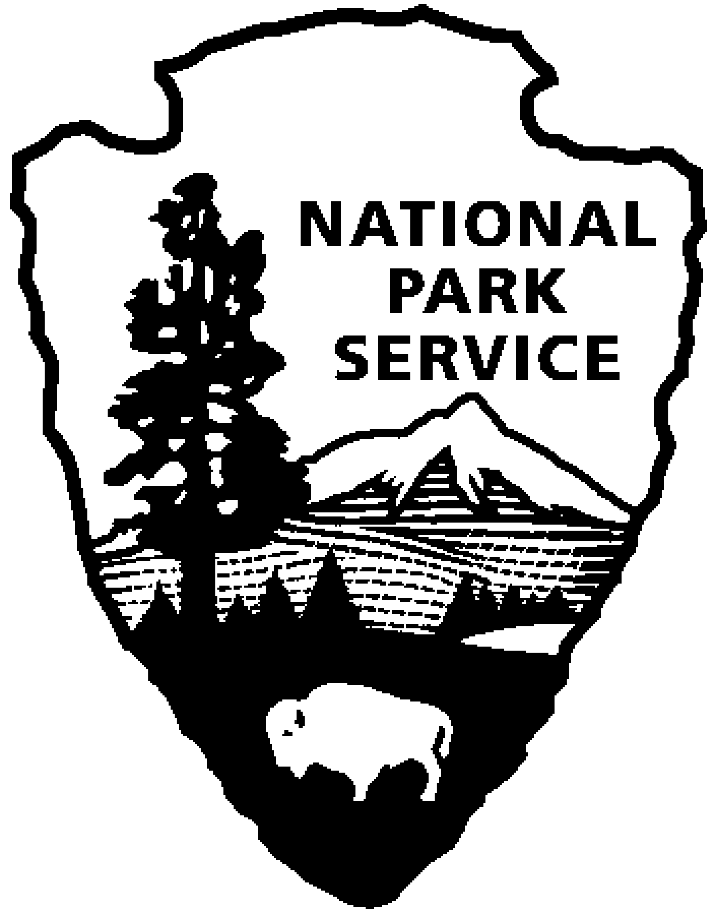
Upper Delaware S&RR News Release
Release date: Immediate
Contact(s): Ingrid Peterec
Ingrid_peterec@nps.gov
(570) 685-4871 x6609

Celebrate National Public Lands Day with Upper Delaware Scenic and Recreational River
Upper Delaware Scenic and Recreational River invites you to participate in a national day of community service on September 22nd

Beach Lake, PA – On Saturday, September 22nd, Upper Delaware Scenic and Recreational River will celebrate National Public Lands Day. National Public Lands Day is a nationally celebrated event that strives to get people out into our nation’s beautiful publicly owned lands, including national and state parks. To celebrate, Upper Delaware Scenic and Recreational River will be hosting a park-wide volunteer event, which will focus on maintaining Upper Delaware’s treasured cultural resources.
This year, volunteers are needed to assist rangers in cleaning up the Delaware and Hudson Canal at the Corwin Farm Ranger Station. The Corwin Farm was vital stop along the canal and provided opportunity for canalers to stock up on needed supplies and food provisions for their journey from Honesdale, PA to Kingston, NY.
This is a great opportunity to get outdoors, enjoy scenic views along the river, and help preserve the historic integrity of the D&H Canal. Volunteers will learn to identify many non-native invasive plant species and assist rangers by removing them, in turn helping to restore native plant populations. Tools and gloves will be provided to volunteers, however volunteers should be sure to wear close-toed shoes, bring plenty of water, sunscreen, insect repellent, a hat, and a bagged lunch.
National Public Lands Day at Upper Delaware will begin with registration and site orientation from 9:30-10:00am on September 22nd at the Corwin Farm Ranger Station, 2995 State Rte. 97 in Pond Eddy, NY 12770. At 10:00am we will break into our volunteer groups and move to the designated work locations. The event will conclude before 2:00pm.
The National Park Service relies on volunteers to achieve its goal of stewardship, and appreciates the hard work and commitment of volunteers who have helped to keep the Upper Delaware River and its historic properties beautiful. We look forward to seeing you at our National Public Lands Day Celebration!

For information on this volunteer event visit https://www.neefusa.org/npld/upper-delaware-scenic-recreational-river/corwin-farm-delaware-hudson-canal-clean or to register, please call Susie Kaspar at 570-685-4871 x 6610 or send an e-mail to susie_kaspar@nps.gov by September, 21st. For additional information about Upper Delaware Scenic and Recreational River visit our website at www.nps.gov/upde. Don’t forget to like us on Instagram and follow us on Facebook at www.facebook.com/updeNPS.

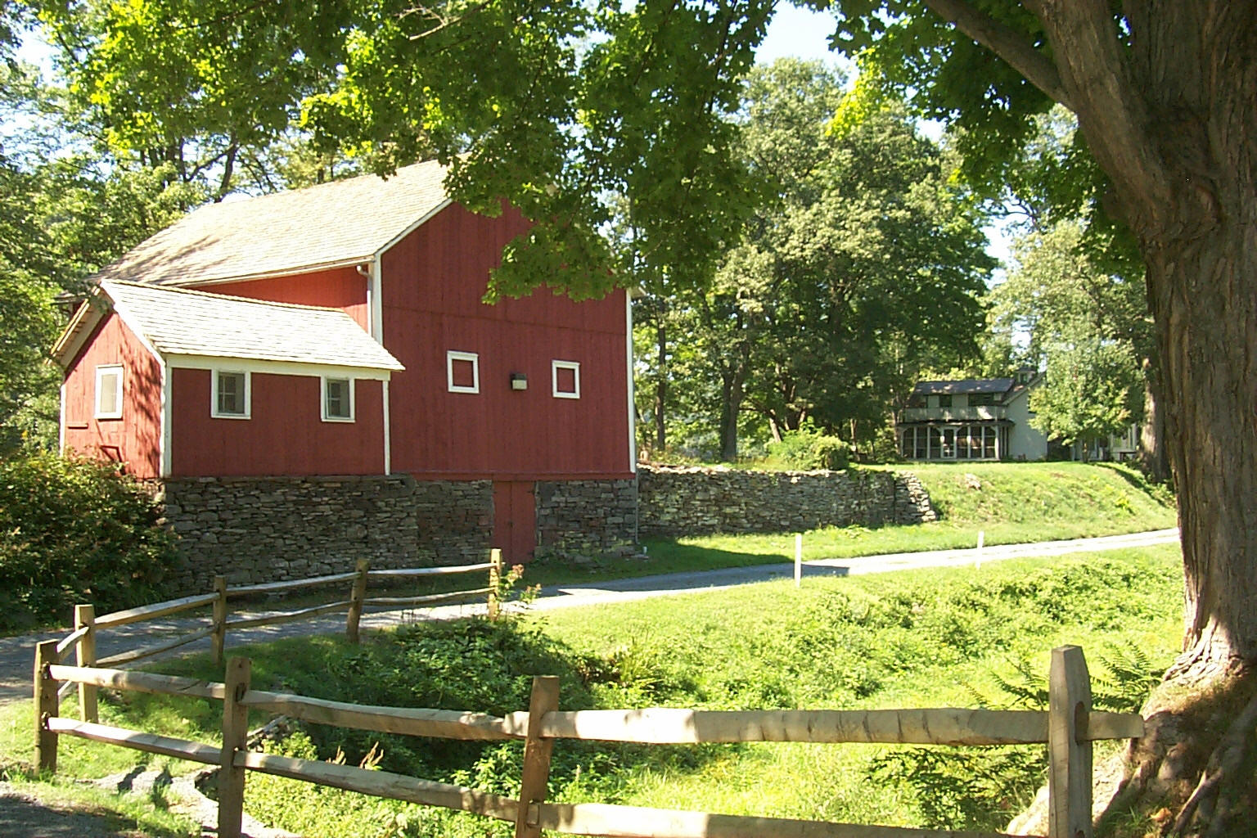
Photo: The historic Corwin Barn located at Upper Delaware Scenic & Recreational River.

About the National Park Service: More than 20,000 National Park Service employees care for America’s 417 national parks and work with communities across the nation to help preserve local history and create close-to-home recreational opportunities. Learn more at www.nps.gov.

